ASSIGNMENT 8.2

Blaine Blasdell

2020-07-26

# Assignment 8.2

## Question 8.2a

1. Plot the data from each dataset using a scatter plot.

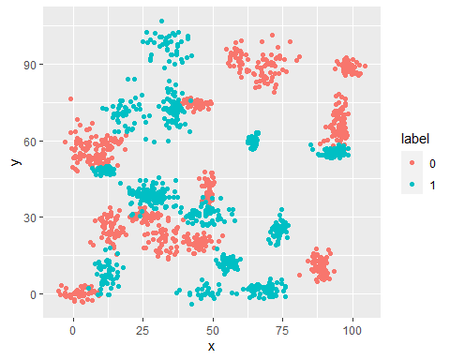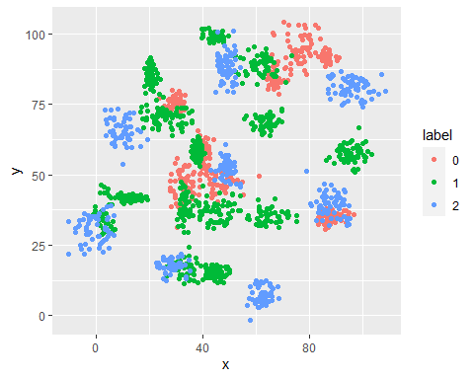

## Question 8.2b

1. Fit a k nearest neighbors model for each dataset for k=3, k=5, k=10, k=15, k=20, and k=25. Compute the accuracy of the resulting models for each value of k. Plot the results in a graph where the x-axis is the different values of k and the y-axis is the accuracy of the model.

##   
## Call:  
## glm(formula = label ~ x + y, family = binomial(), data = bin_train)  
##   
## Deviance Residuals:   
## Min 1Q Median 3Q Max   
## -1.3728 -1.1697 -0.9575 1.1646 1.3989   
##   
## Coefficients:  
## Estimate Std. Error z value Pr(>|z|)   
## (Intercept) 0.424809 0.117224 3.624 0.00029 ***  
## x -0.002571 0.001823 -1.411 0.15836   
## y -0.007956 0.001869 -4.257 2.07e-05 ***  
## ---  
## Signif. codes: 0 '***' 0.001 '**' 0.01 '*' 0.05 '.' 0.1 ' ' 1  
##   
## (Dispersion parameter for binomial family taken to be 1)  
##   
## Null deviance: 2075.8 on 1497 degrees of freedom  
## Residual deviance: 2052.1 on 1495 degrees of freedom  
## AIC: 2058.1  
##   
## Number of Fisher Scoring iterations: 4

## x y  
## 1 3 97.17172  
## 2 5 97.17172  
## 3 10 96.96970  
## 4 15 97.17172  
## 5 20 96.56566  
## 6 25 97.17172

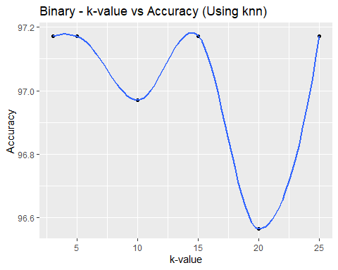

##   
## Call:  
## glm(formula = label ~ x + y, family = binomial(), data = tri_train)  
##   
## Deviance Residuals:   
## Min 1Q Median 3Q Max   
## -1.9906 -1.1552 0.5969 0.7718 1.2460   
##   
## Coefficients:  
## Estimate Std. Error z value Pr(>|z|)   
## (Intercept) 2.771616 0.189883 14.596 < 2e-16 ***  
## x -0.014758 0.002285 -6.460 1.05e-10 ***  
## y -0.015715 0.002428 -6.473 9.60e-11 ***  
## ---  
## Signif. codes: 0 '***' 0.001 '**' 0.01 '*' 0.05 '.' 0.1 ' ' 1  
##   
## (Dispersion parameter for binomial family taken to be 1)  
##   
## Null deviance: 1767.9 on 1567 degrees of freedom  
## Residual deviance: 1663.4 on 1565 degrees of freedom  
## AIC: 1669.4  
##   
## Number of Fisher Scoring iterations: 4

## x y  
## 1 3 63.89961  
## 2 5 65.05792  
## 3 10 65.44402  
## 4 15 65.25097  
## 5 20 63.70656  
## 6 25 63.32046

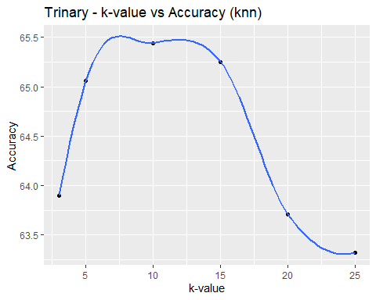

## Question 8.2c

1. In later lessons, you will learn about linear classifiers. These algorithms work by defining a decision boundary that separates the different categories. Looking back at the plots of the data, do you think a linear classifier would work well on these datasets?

Answer - Based on what I see # References